Facility Checker App (FCA)
User Guide
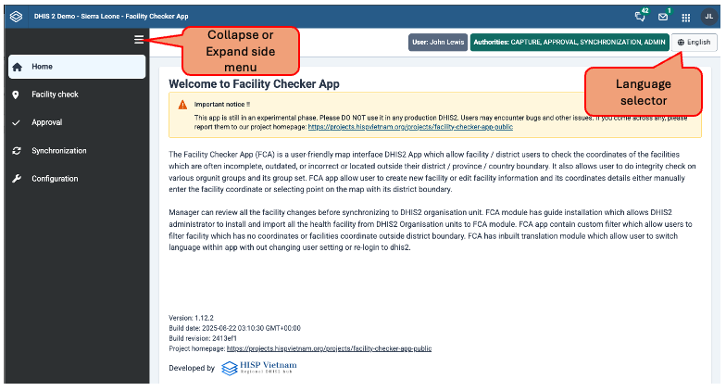

DHIS2 Facility Check App (FCA) user guide is designed based on the functional area of user operation. The guide is categories by user guide for
- District or health facility users: who manage health facility information such as its coordinates, facility name, code, its active status (open/close), its association with Orgunit group in group set.
- Province or Regional users: Basically, health managers or administrators who oversee district or facility information and are in charge of reviewing requests from peripheral health administrative units.
- National DHIS2 core admin users: DHIS2 national users with superuser authority and usually maintain DHIS2 organization unit and other metadata.
- National DHIS2 core team users: Users who are in charge of DHIS2 translation and user group.

District / Facility users:
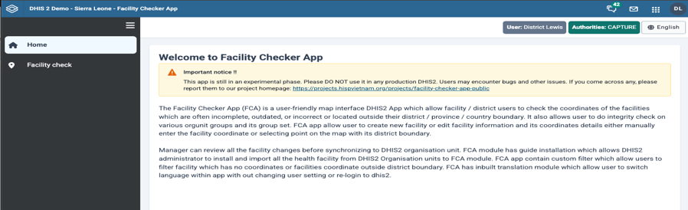
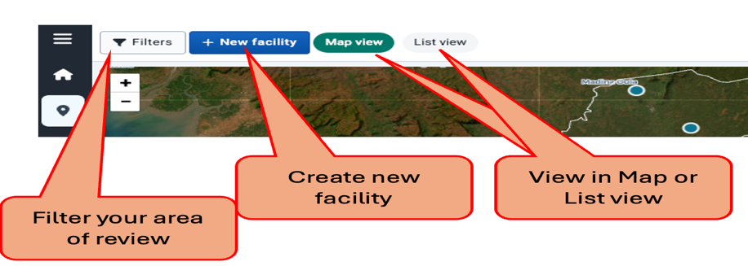
Facility Check module: This module allows users to review and update the health facility details such as facility coordinates, demographic information, their association with orgunit group in group set.

Workflow Example:
Editing existing facility:
- Select District or entire Province you want to review facility details
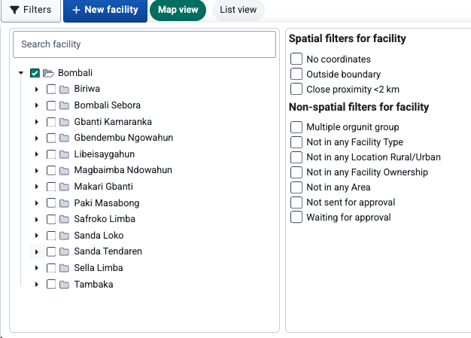
- Apply filters
  - Appling Spatial filters such as
    - No coordinates: will filter all the facilities which don’t have GPS coordinates. This filter can only be reviewed in “List View”.

    - Outside boundary: Will filter all the facilities which are located outside the district boundary. This filter can be reviewed in both Map and List view.
    - Close proximity <2 km: will filter all the facilities which are located close to each other with in proximity of under 2 kilometers. This filter can be reviewed in both Map and List view.
  - Appling non-spatial filter
    - Multiple orgunit group: will filter all the facilities which are associated in multiple orgunit groups in a Group Set. Recommended to review in List View as some facility without coordinates might be missed in Map view.
    - Not in any <Orgunit Group Set>: will filter all the facilities which are not associated to any Orgunit groups within a Orgunit Group Set. For example: Facility Type, Location Rural/Urban, Facility Ownership and Area are Orgunit group set in demo instance of DHIS2.
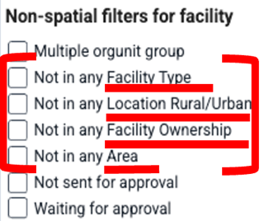
    - Not sent for approval: will filter all the facilities which are edited but not submitted for approval.
    - Waiting for approval: will filter all the facilities which are edited and sent for approval.
- Editing facility details:
  - Updating coordinates using “Map view”
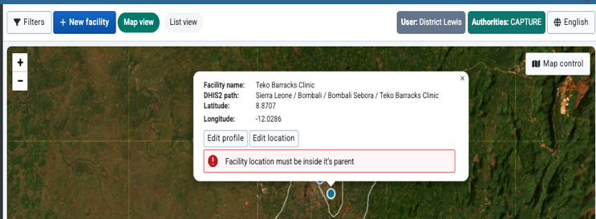
    - Click on edit location
    - Move the facility to new location
    - Click on Save
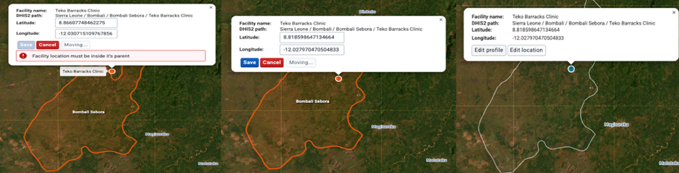

  - Updating coordinates using “List view”
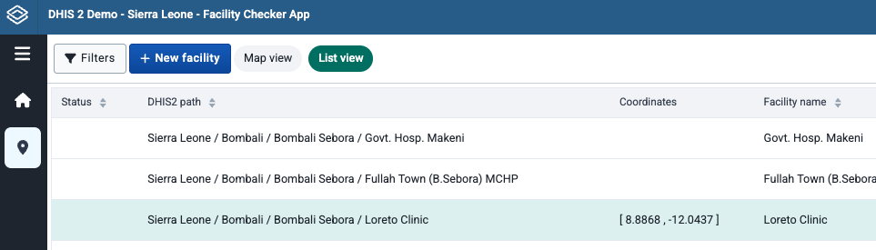
    - Select the facility you want to edit
    - Update coordinates either by manually entering coordinates or choose location on map
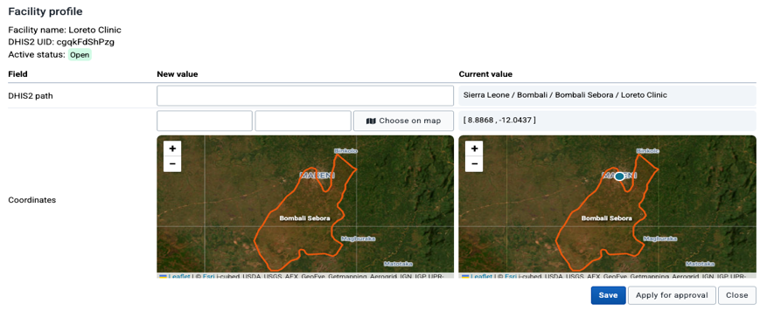
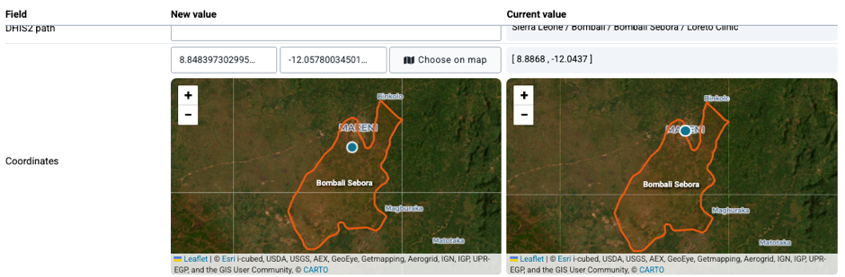
    - Update other
- Review facility and submit for approval
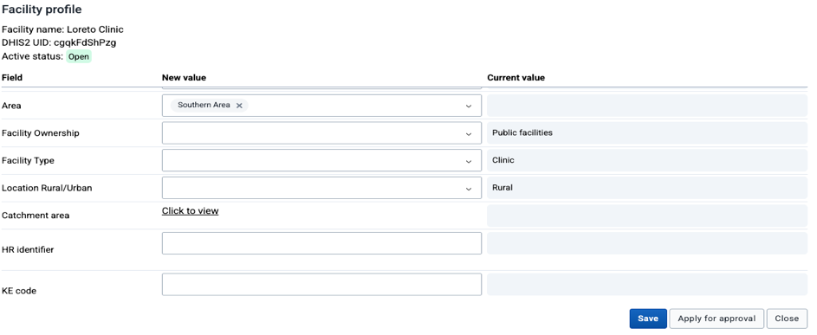
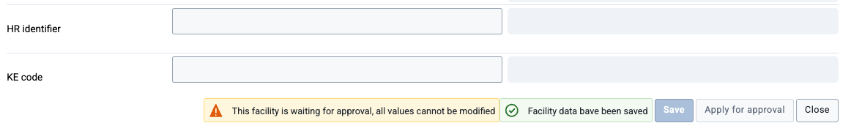

Creation of new facility:
Workflow
- Click on new facility button

- Select district where new health facility is located
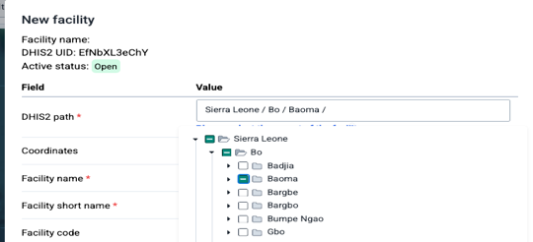
- Enter the facility coordinates manually or choose the location of the health facility on the map and click on Apply
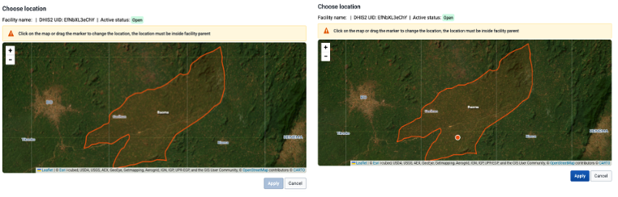
- Fill in all the mandatory fields such as Facility Name, short name, opening date and other relevant information
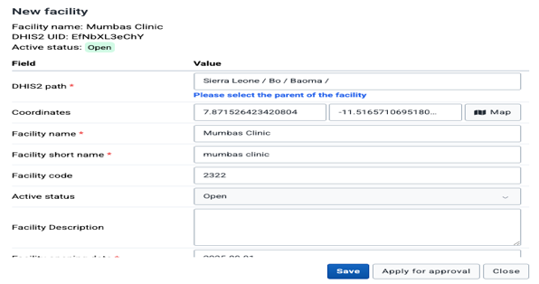
- Click on Save or Apply for approval button.

Province / Regional / National level Program managers or Administrator:
Approval Module: In this module, users such as health manager or administrator can review individual facility changes made by sub-national level users. All the changes are categorized based on the nature of changes to facility information such as
- Changes in GPS coodinates
- Changes in Orgunit groups in a Group Set
- Change in reporting hierarchy, when a facility is moved from one district to another district.
- Change in profile such as change in facility contact details or phone number, facility code etc.
- New facility created
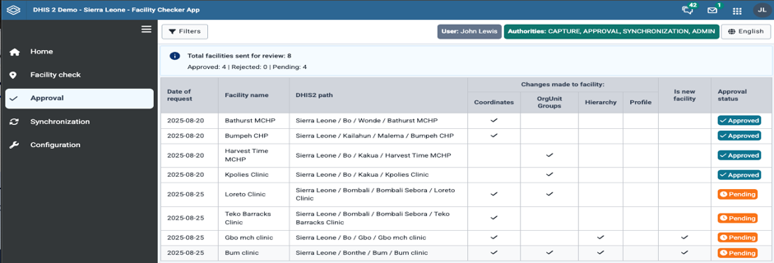

Workflow:
- Click on the facility to review the changes requested by sub-national level for approval.
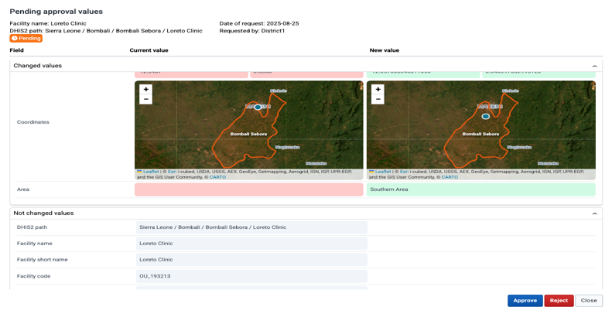
- Review all the change requested for the facility. All the changes would be in under changed values section. Each change will display current value and new values requested.
- Approve change by click on “Approve” button. Once facility changes are approved it cannot be reverted.
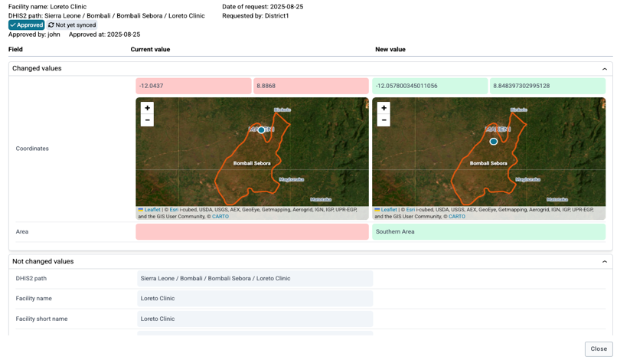
- Reject changes by click on “Reject” button and specific reason for reject
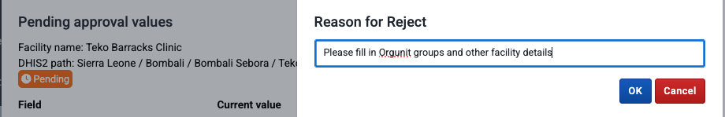
- User can review all the approval and reject status in approval main screen.
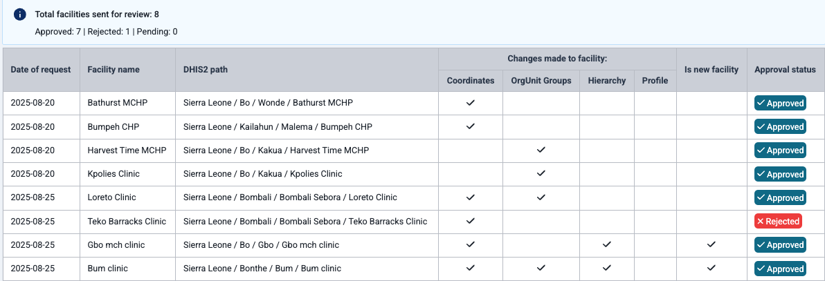

National DHIS2 core admin user or team.
Synchronization Module: Facility Checker App Sync module allows DHIS2 core admin user, who has superuser authority to update DHIS2 organisation unit can use this module.
Workflow:
- Click on “Sync” button to synchronize all the approved changed to DHIS2 organisation unit module. FCA Sync module would highlight number of facilities that would be push to DHIS2 organisation unit module along with its category of changes such as coordinates update, orgunit groups, reporting hierarchy and facility information.
- All the changes are created in FCA tracker program. User can review all the changes by using line listing app.
Note: Run the DHIS2 Analytics Tables before reviewing all the changes using line listing app of DHIS2,.
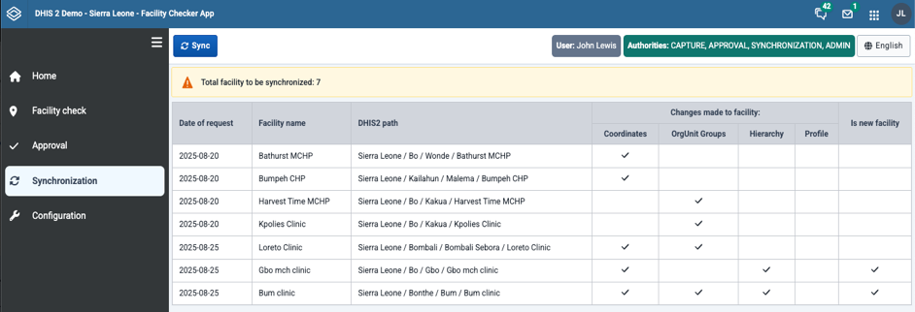

National level DHIS2 core team users.
Configuration Module: Users having access to this module can add and edit User Interface (UI) language and can assign users to respective FCA user authorities such as Capture, Approval, Synchronization and Admin.
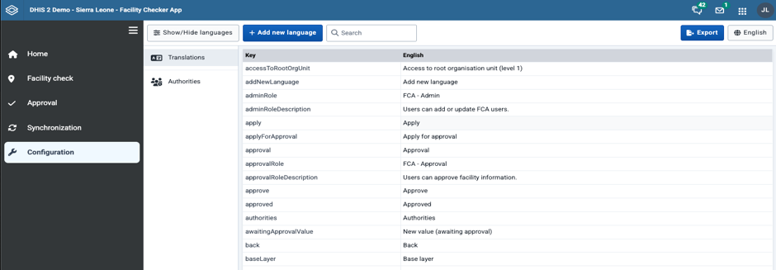

Workflow:
Edit FCA UI language translation:
- Select one or more language which you want to update the UI translation.
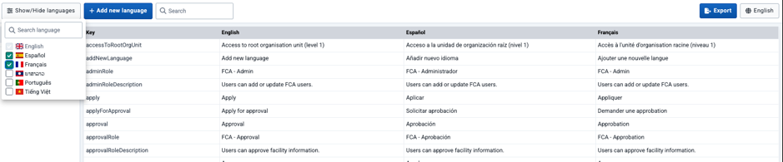
- Click on the cell you want to update the UI translation
- Click on green tick symbol to save the changes
Add new FCA UI language translation:
- Click on “Add new language”, search of language you want to include
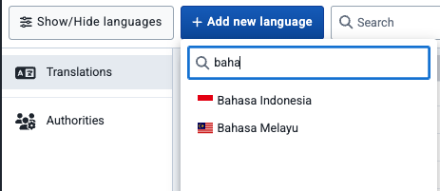
- Fill in appropriate language translation for each key.
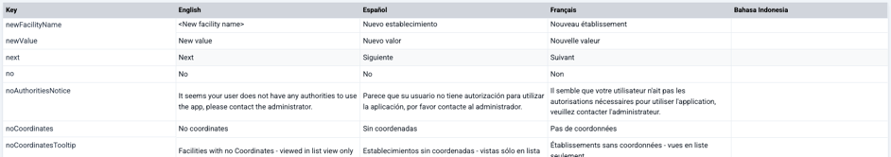
- Click on Language “English” button to see new UI language translation
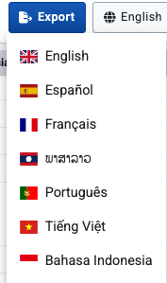
Note: You can export the keys and current UI translation into Excel and fill in all the necessary UI translation.

Adding user to FCA Authorities
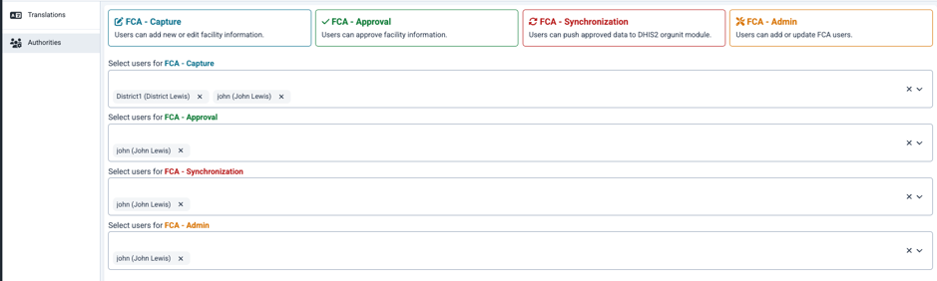
Workflow
- Select FCA authority for which you want to add or edit users
- Search user or user group you want to include for FCA authority


