Facility Checker App (FCA) Installation Manual

1. Introduction
The Facility Checker App (FCA) is a DHIS2 app designed to help health information officers and system administrators validate and correct health facility locations. This guide provides step-by-step instructions for installing the FCA on a DHIS2 instance.

2. Prerequisites
- DHIS2 version: 2.40 or higher
- User must have superuser authority and access to root Organisation Unit in DHIS2
- Facility organisation unit hierarchy configured in DHIS2
- At least one Orgunit group Set should be configured in DHIS2 with include all the health facilities in their respective Orgunit Groups
- Download the latest FCA installation package (.zip) from https://github.com/HISPVietnam/facility-checker-app/releases. Please ensure the zip file name should be fca.zip

3. Installation Steps

Step 1: Log in to DHIS2
Open your browser and log in to your DHIS2 instance using Administrator credentials.
Note: Please test the Facility Checker App (FCA) in the development instance before installing it in production server.
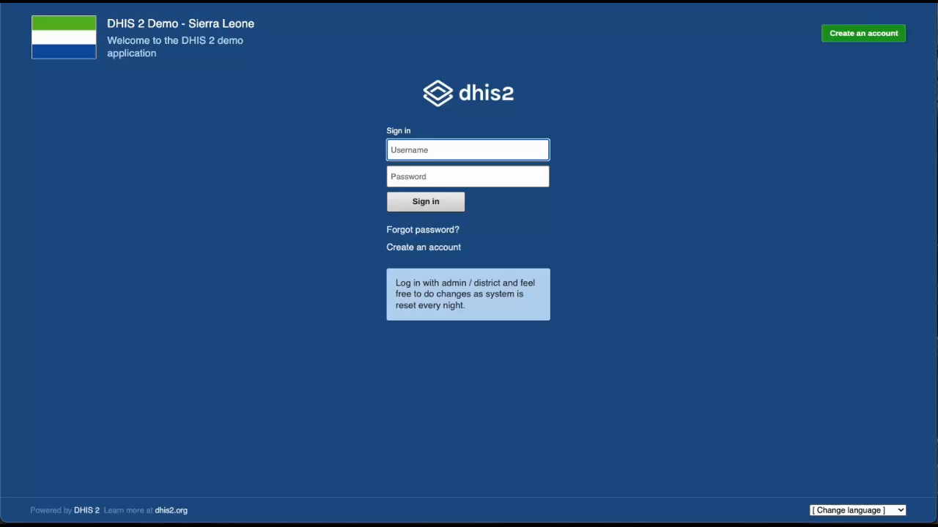

Step 2: Open App Management
Navigate to Apps → App Management from the top-right menu.
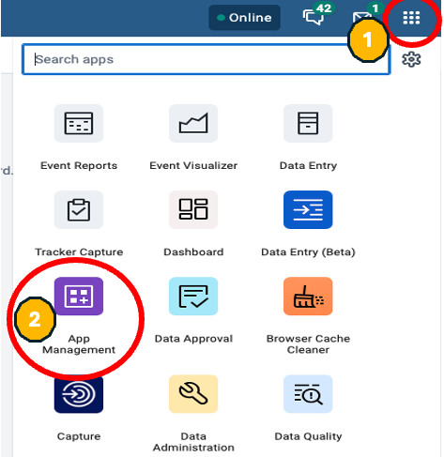

Step 3: Upload the FCA Package
Click on manual Install → Upload App, then select the fca.zip file.
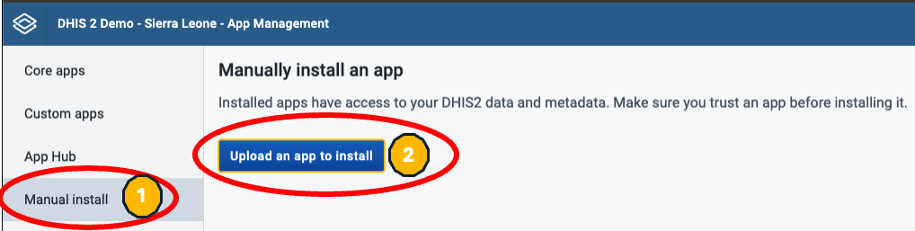

Step 4: Starting FCA installation guide
Refresh the page or click on the DHIS2 logo on the top left corner. Navigate to Apps → Facility Checker App and follow the Guided Installation module to import facilities and user access to FCA app.

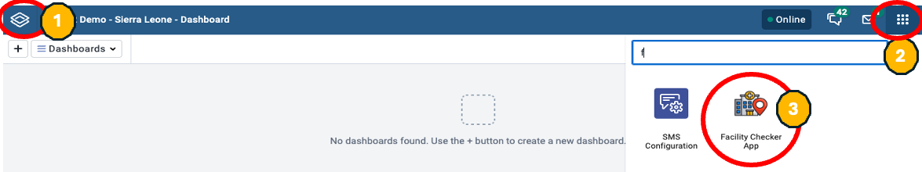
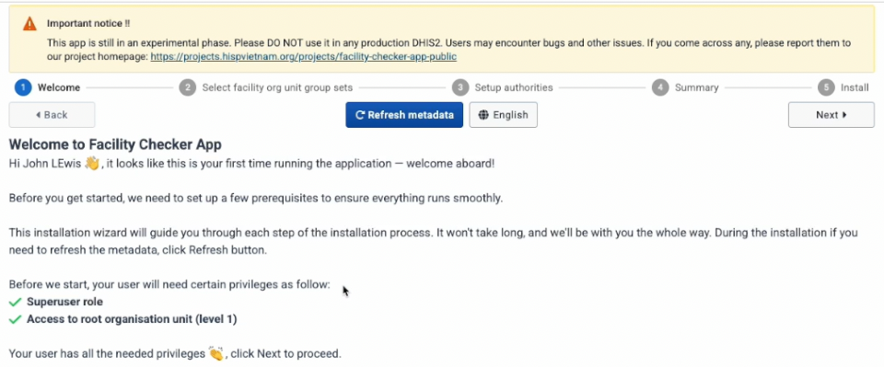

Step 5: Choosing facilities to import in FCA app
Select one or more Orgunit Group Set which contains all the health facilities in your DHIS2 Instance. FCA app will skip organisation units which have geometric type - polygon. For Example: provinces or districts which usually are polygons by nature.
After selecting your orgunit group set please review and proceed to the next screen.

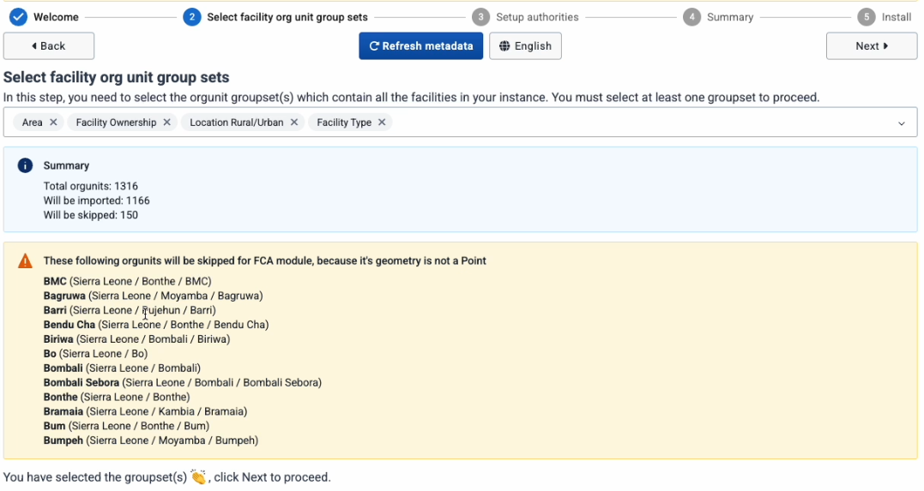

Step 6: Setting up user access to FCA App
FCA app contains four authorities:
- FCA Capture authority: allow users to add or edit new facility information such as facility GPS coordinates, their association with orgunit groups, demographic information and reporting hierarchy.
- FCA Approval authority This authority is for province or regional managers, or health program managers or administrator who can review and approve changes made to the facilities by end users
- FCA - Synchronization authority: This authority should be given to the national DHIS 2 core team who have authority to manage and maintain DHIS 2 metadata. Users should have a “superuser” role and access to the root Organisation unit in DHIS2. This authority in FCA will allow users to Synchronization approved facility changes to DHIS 2 organisation unit module.
- FCA - Admin authority: This authority should be given to national DHIS 2 core team, or Health managers or Administrator who can add end users to all the FCA authority and also can update UI translation in FCA app.
FCA app requires at least one user in each of these four authorities. Additional users can be added or removed after installation.
After assigning users to their respective FCA authorities move to the next screen.

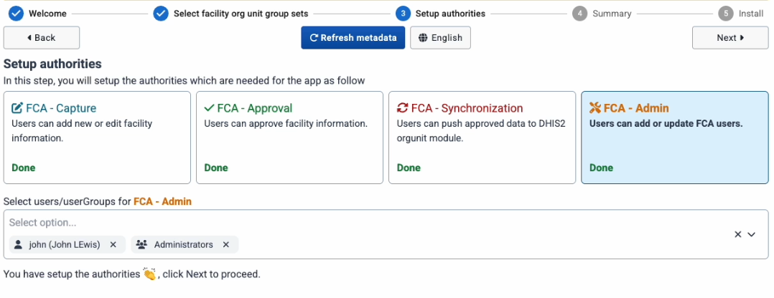

Step 7: Review and Install FCA app
Please review the number of facilities and user access selected and proceed to the next screen. Click on the "Install" button. FCA app will import all the necessary metadata needed for FCA app use including selected facilities in orgunit group sets and user access for FCA app.
Once the install is complete click on the "OK" button. User access and its authorities to take effect in your DHIS 2 instance, you need to re-login to your DHIS2 instance. FCA app will automatically redirect you to the login screen.
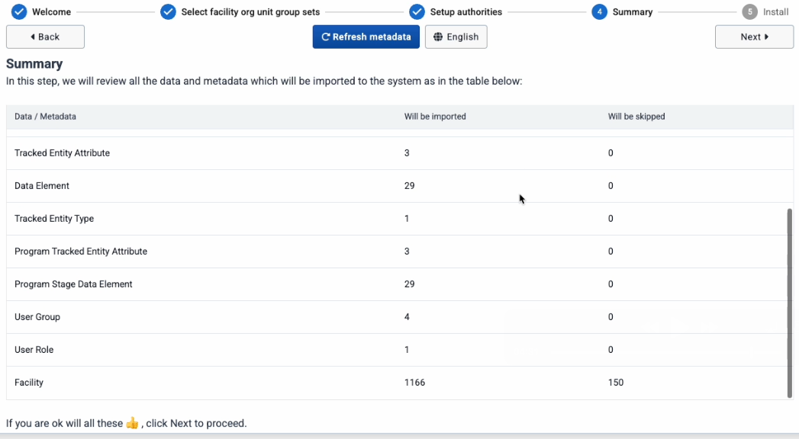
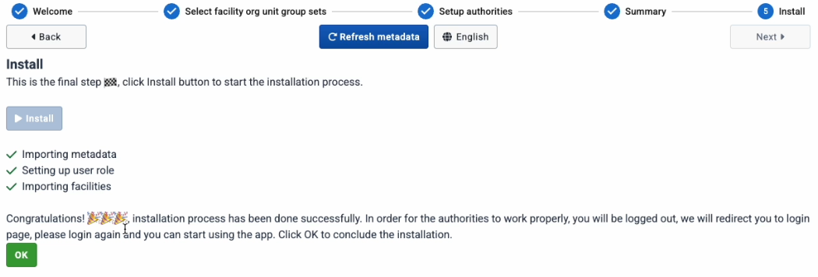

Step 4: Verifying FCA app Installation
Navigate to Apps → Facility checker App from the top-right menu. Please review the Facility Checker App Version either on the home page or by clicking on your profile located at the top-right menu.
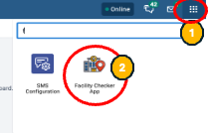
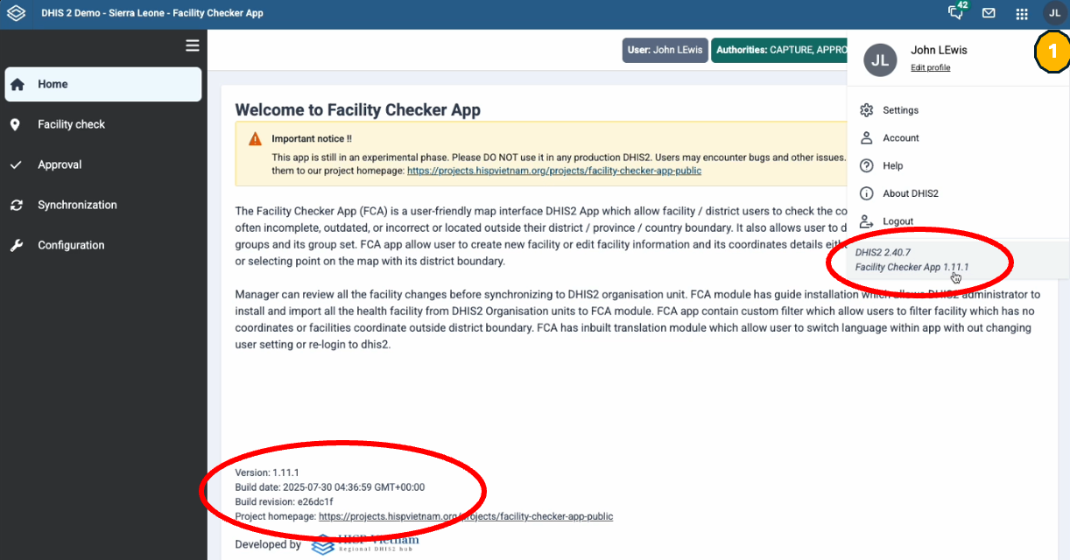

4. Resources
Facility Checker App Project Page: https://projects.hispvietnam.org/projects/facility-checker-app-public/
GitHub source code and App download: https://github.com/HISPVietnam/facility-checker-app/

